CEFR Companion Volume implementation toolbox

Classroom activity: Mediating texts – Explaining data in speech or in writing
Title: Research results
Language: English
CEFR Level: B2/C1
Target group: students at university or in vocational training
Purpose: Mediating texts / explaining data
Authors: VITbox team

Goals of the activity:
- transforming data presented in graphs, charts or diagrams into a spoken and written text;
- describing, commenting and interpreting salient points.
0. Introduction
Students are asked to prepare an article on their research topic and need to get familiar with ways of presenting and explaining data.
1. Warm-up
The activity starts with a discussion on ways of presenting data in charts and diagrams, different types of diagrams and their purposes and the language used for describing trends.
2. Task 1: Reading a literary review and analysing graphs and charts – preparation
Students read a fragment of an academic article which summarises previous research in the field and is accompanied by the data shown in charts and diagrams. They are asked to focus on the way the data is presented in the graphic form.
3. Task 2: Interpreting the information shown in diagrams and charts
The students are asked to interpret and discuss the information presented in the article’s diagrams. They are also asked to evaluate their usefulness and the efficiency in presenting information. They are encouraged to think about alternative ways of data presentation.
4. Task 3: Peer feedback and class discussion
The activity may be followed with a class discussion on the advantages and disadvantages of the graphs and diagrams in the article.
5. Task 4: Implementing newly gained skills in students’ own research and writing
Students are then invited to prepare diagrams and/or charts of their own research data and present and describe it in a scientific paper.
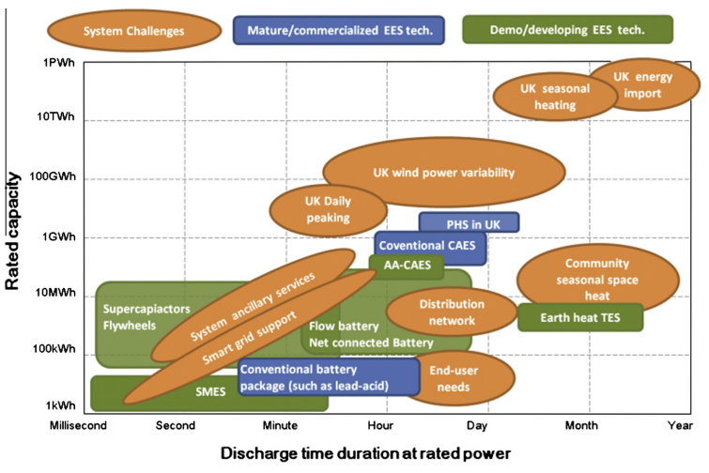
Source: Overview of current development in electrical energy storage technologies and the application potential in power system operation (https://www.sciencedirect.com/).

Descriptors: CEFR level B2
CEFR Descriptor Scheme:  Mediation/ Mediating a text | Scale:  Explaining data in speech / in writing
Descriptors:
Can interpret and describe reliably (in Language B) detailed information contained in complex diagrams, charts and other visually organised information (with text in Language A) on topics in their fields of interest.

Descriptors: CEFR level C1
CEFR Descriptor Scheme:  Mediation/ Mediating a text | Scale:  Explaining data in speech / in writing
Descriptors:
Can interpret and describe clearly and reliably (in Language B) the salient points and details contained in complex diagrams and other visually organised information (with text in Language A) on complex academic or professional topics.

